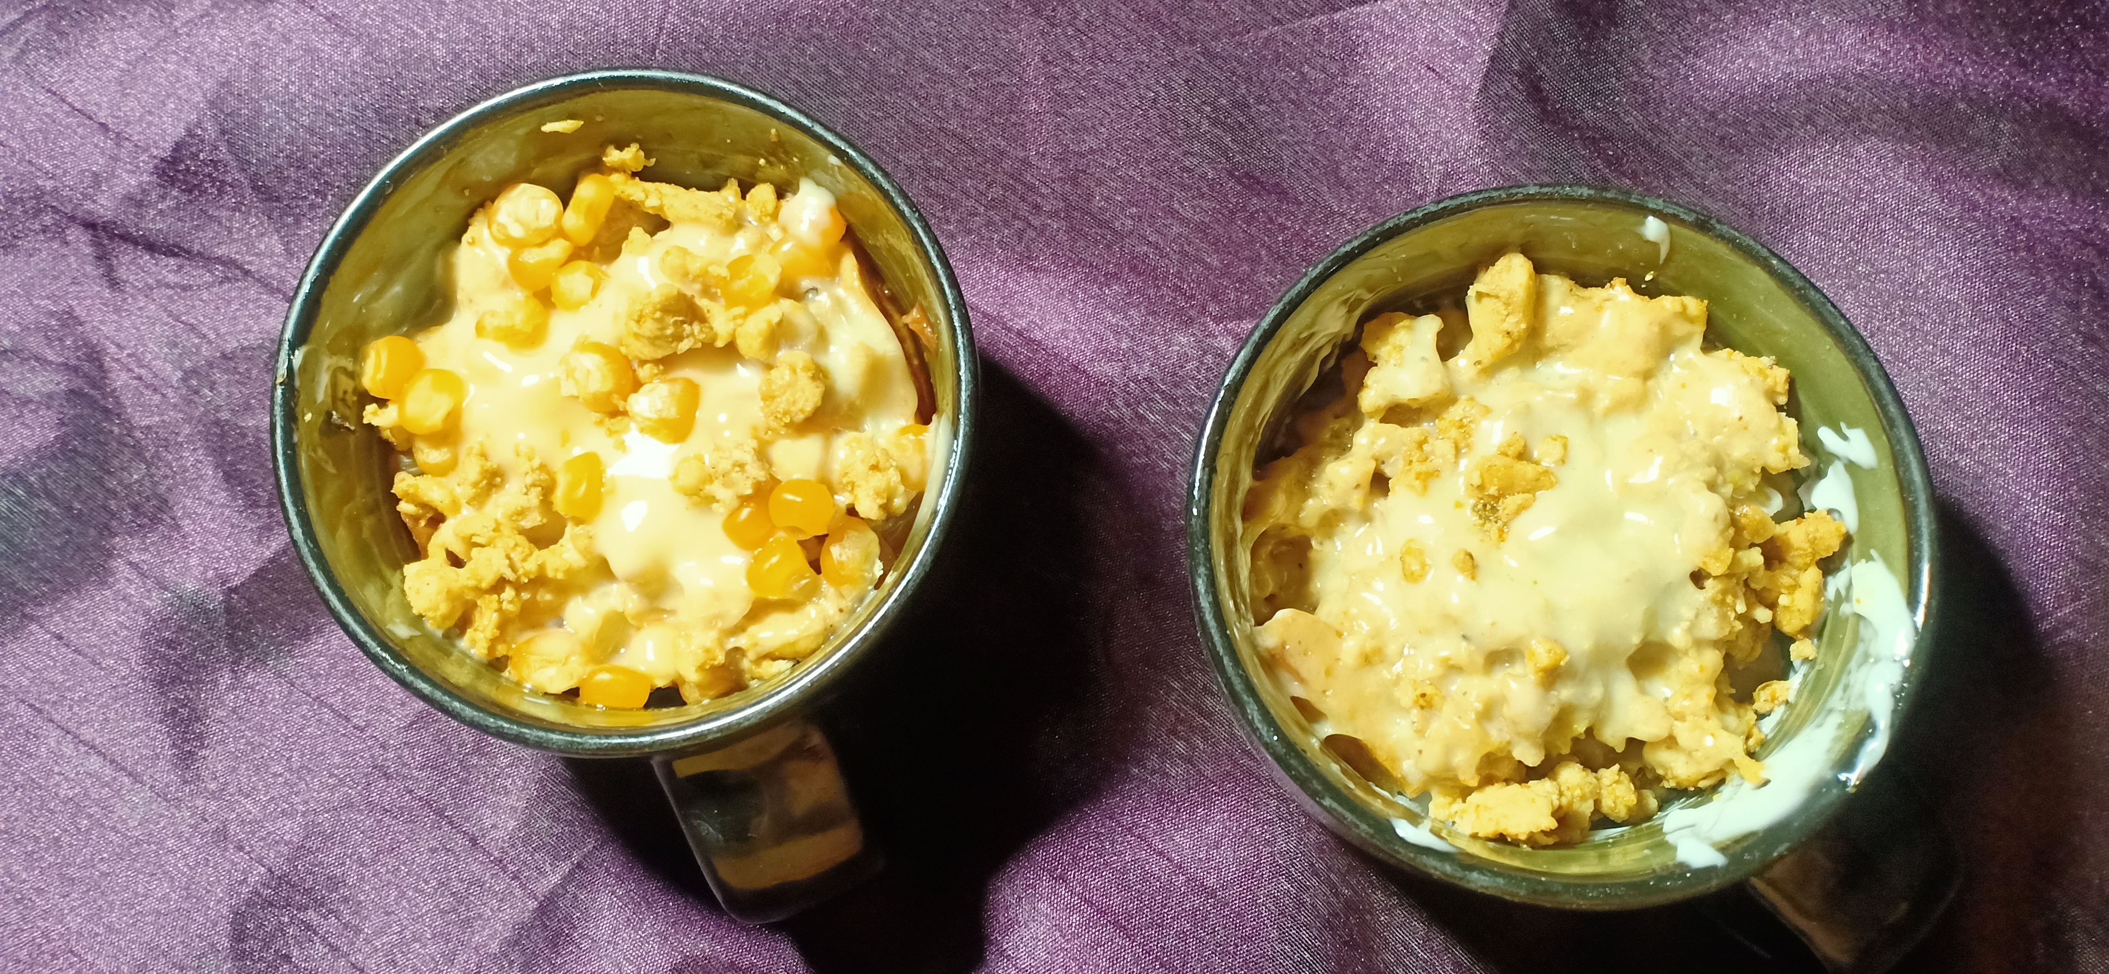

**Ingredients**

Serving 5-7

**For fries**

* 2 kg potato
* 3 kg water
* 1.5 tablespoon salt

**For chicken filling**

* 1 tablespoon ginger garlic paste
* ½ kg chicken
* 1- 2 tablespoon soya sauce
* 1 tablespoon tikka masala

**For Assembling**

* 1 cup corn
* Cheese slice
* Pizza sauce

**Directions**

**For fries**

* Bring water to boil then add potatoes in fries cut for 4 minutes then dry it under fan for 1 hour
* Fry that fries on high flame to slightly golden

**For chicken filling**

* Add ginger garlic paste in oil and sauté it then add chicken and fry until it turns white
* Then Add tikka masala and soya sauce.

**For Assembling**

* Add fries in cup then add pizza sauce and mix it then add 2 tbs chicken and 2 tbs corn .
* Add Cheese slice on top of it microwave it for 1 minute and it is ready to serve .